

BERZIET UNIVERSITY

FACULTY OF ENGINEERING AND TECHNOLOGY

DEPARTMENT OF COMPUTER ENGINEERING

ENCS3320, COMPUTER NETWORKS

Project # 1

instructor : Dr.Imad Tartir

BY : Malak Ayyash 1192567

BY : Rama Abdelrahman 1191344

BIRZEIT

May–2022

# Abstract:

The goal of this project is to learn more about networking and how to use sockets, html, and CSS to develop our own web server and open it as a local host using Pycharm and Visual Stdio in python language .

I

Table of Contents

1. AbstractI
2. [part 1 1](#_Toc2594736)

[2.1 Ping the device in the same network 1](#_Toc2594736)

2.2 ping www.youtube.com 2

2.3 tracert www.youtube.com 3

2.4 nslookup www.youtube.com 4

1. [part 2 5](#_Toc2594736)
2. [conclusion 1](#_Toc2594736)2
3. [References 1](#_Toc2594736)3
4. [Appindex 1](#_Toc2594736)4

II

# . Part 1 2

2.1 Ping a device in the same network, e.g. from a laptop to a Smartphone.

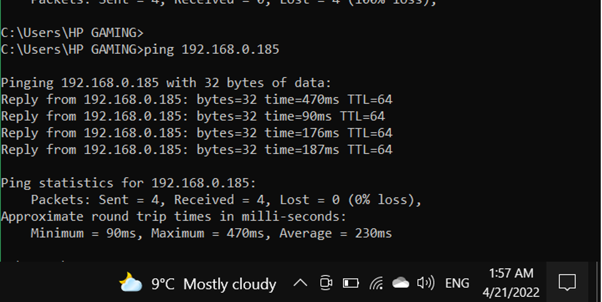

Fig2.1:ping a device on cmd

[1] Ping Test is fast and accurate tool for quality measurements of the Internet connection. It checks delays in millisecond between the computer and selector remote server. The ping value strongly depends on the distance to the server - the bigger distance the ping value is higher.

In the figure 2.1 , four packets of data was sent for another laptop at the same network with its IP(192.168.0.185) with 230 ms average time for each process.

References :

[1] [Ping Test check my ping - ping-test.net](http://ping-test.net/)

2.2 ping [www.youtube.com](http://www.youtube.com).

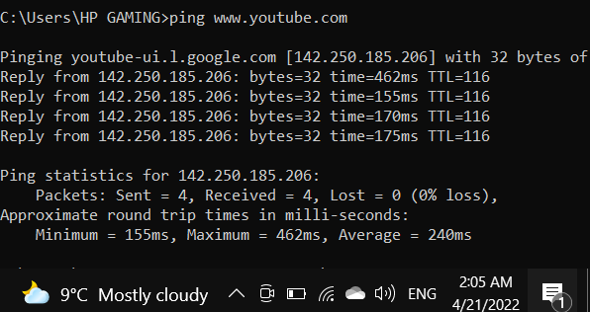

Fig2.2: ping [www.youtube.com](http://www.youtube.com) on cmd

The system sent and received four packets of data from YouTube to determine the minimum, maximum, and average ping values, which are 462ms, 155ms, 170ms, and 172ms, respectively, as shown in figure 2.2.

2.3 tracert [www.youtube.com](http://www.youtube.com).

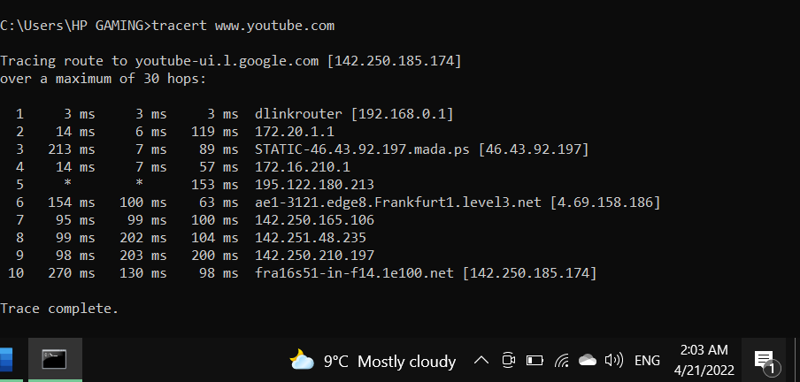

Fig2.3: tracert [www.youtube.com](http://www.youtube.com) on cmd

[2]The tracert command is a Command Prompt command that's used to show several details about the path that a packet takes from the computer or device you're on to whatever destination you specify.

With the tracert command shown in figure 2.3, we're asking tracert to show us the path from the local computer to the network device with the hostname [www.youtube.com](http://www.youtube.com) .

The first column at figure 2.3 shows the hop’s number, while the second, third and fourth columns display the (RTT) for the packet to reach a point . There are three columns because the traceroute sends three separate signal packets. This is to display consistency, or a lack thereof, in the route.

References :

[2] [How to Use the Tracert Command in Windows (lifewire.com)](https://www.lifewire.com/tracert-command-2618101)

2.4 nslookup www.youtube.com.

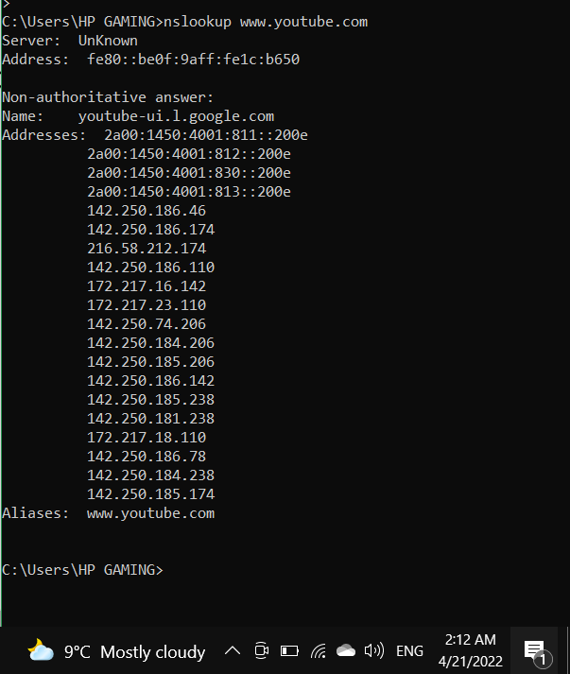

Fig2.3: nslookup www.youtube.com on cmd

NsLookup queries the specified DNS server and retrieves the requested records that are associated with the domain name that provided. These records contain information like the domain name’s IP addresses . in our example , it's for [www.youtube.com](http://www.youtube.com) .

References :

[2] [What Is NsLookup? Use Our Online Tool To Query DNS Records - Network Tools (network-tools.com)](https://network-tools.com/nslookup/)

## 3. part 2

If the request was localhost:9000/ or localhost:9000/en , we response the page at figure 3.1

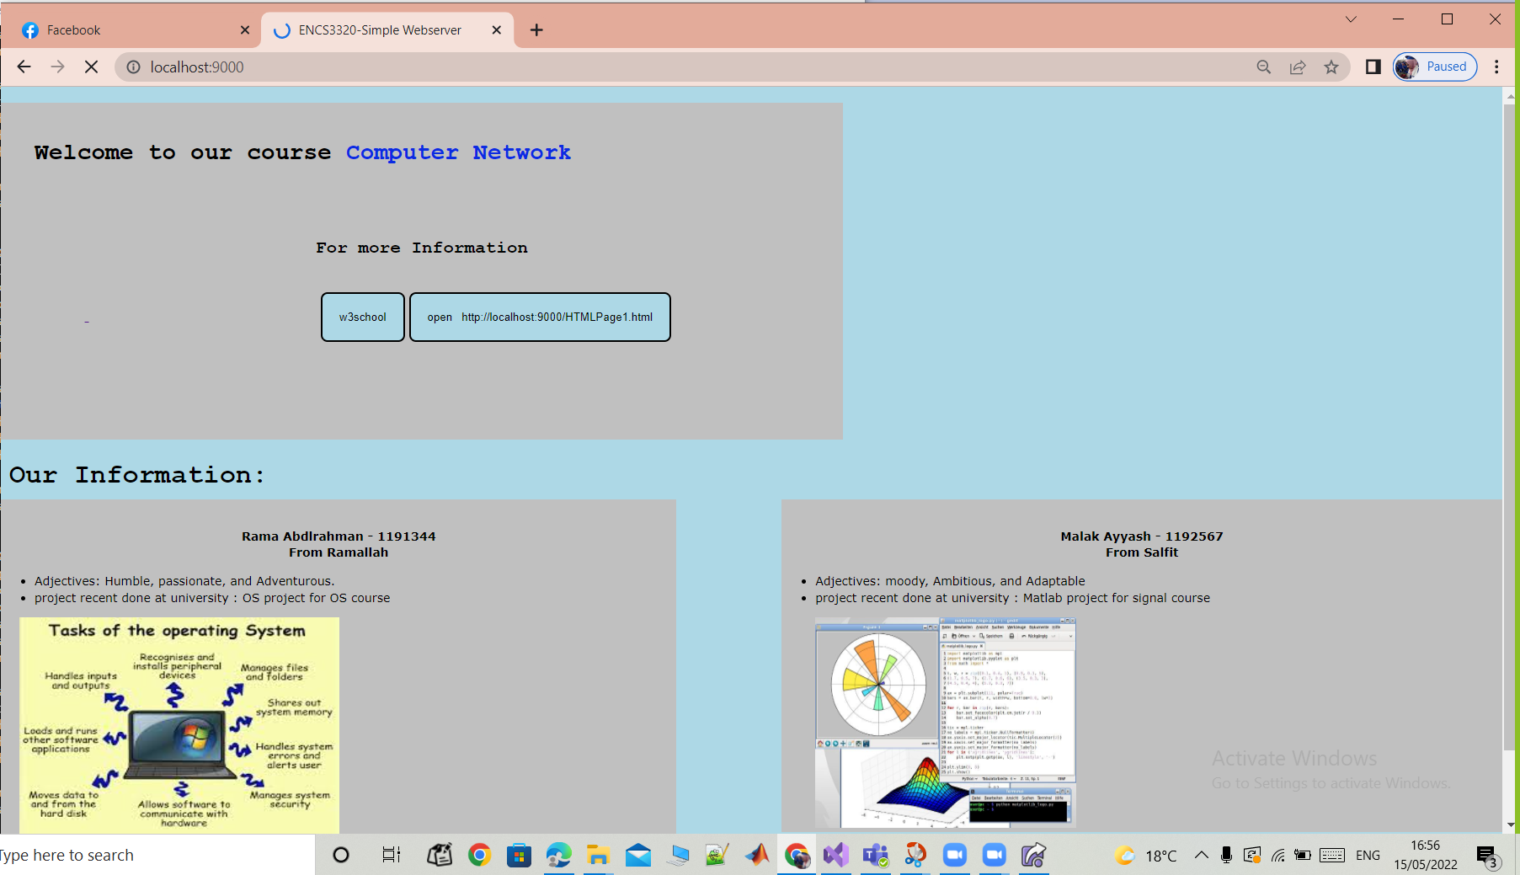

Fig3.1: localhost:9000/en page

From figure 3.1 , we can notice that the title of the page is ENCS3320-Simple Webserver and the page contains welcoming sentence and our information .

If we click at the button called w3school , it takes me to [www.w3school.com](http://www.w3school.com) as shown in figure 3.2

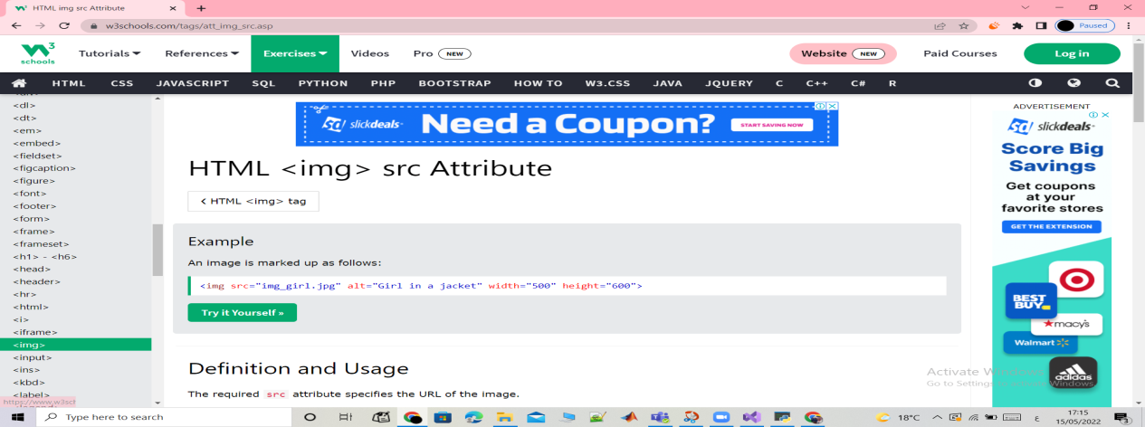

Fig3.2: w3school page

The button next takes us to html page (A link to a local html).

Also the same figure given if opened as .html request.

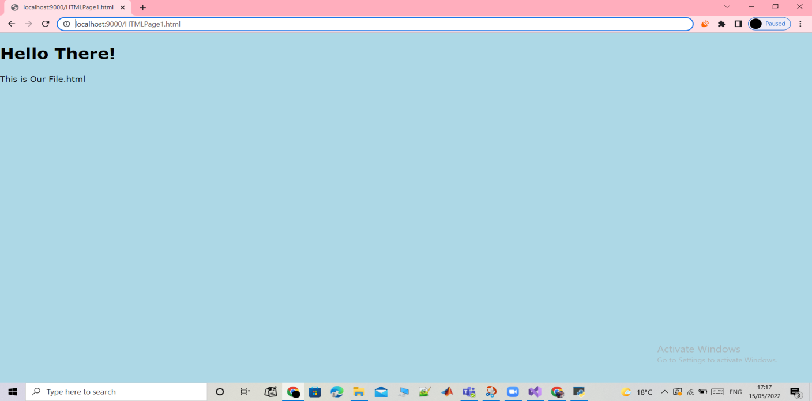 Fig3.3: html page

If the request is (localhost:9000/ar) then the server response the Arabic version of the page as shown in figure 3.4

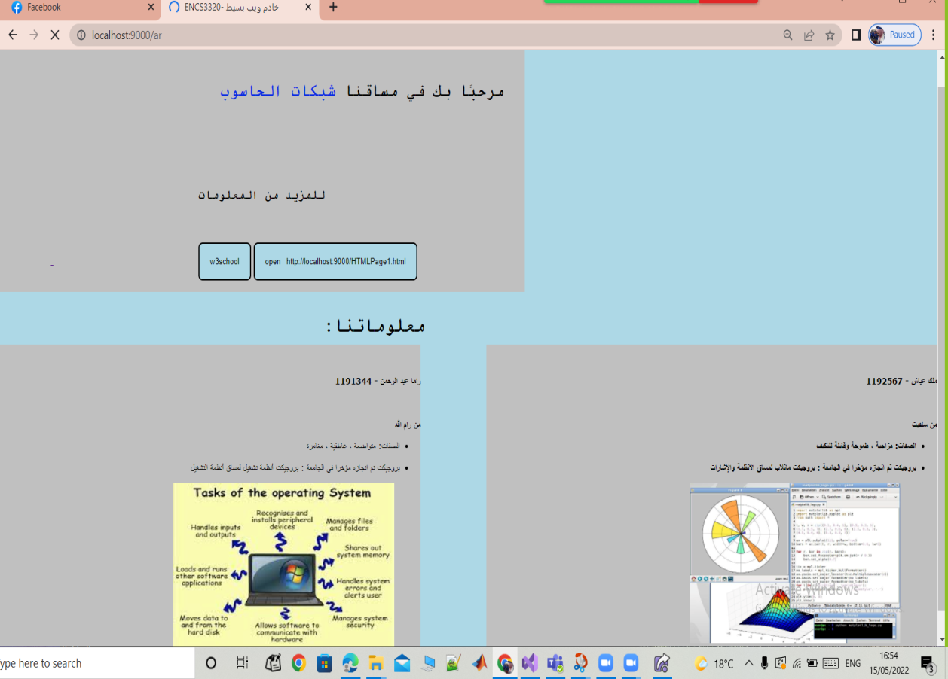

Fig3.4: localhost:9000/ar page

If the request is a .css file, the page .css that contains our code to make the localhost :9000 page look nice will appear as shown in figure 3.5 .

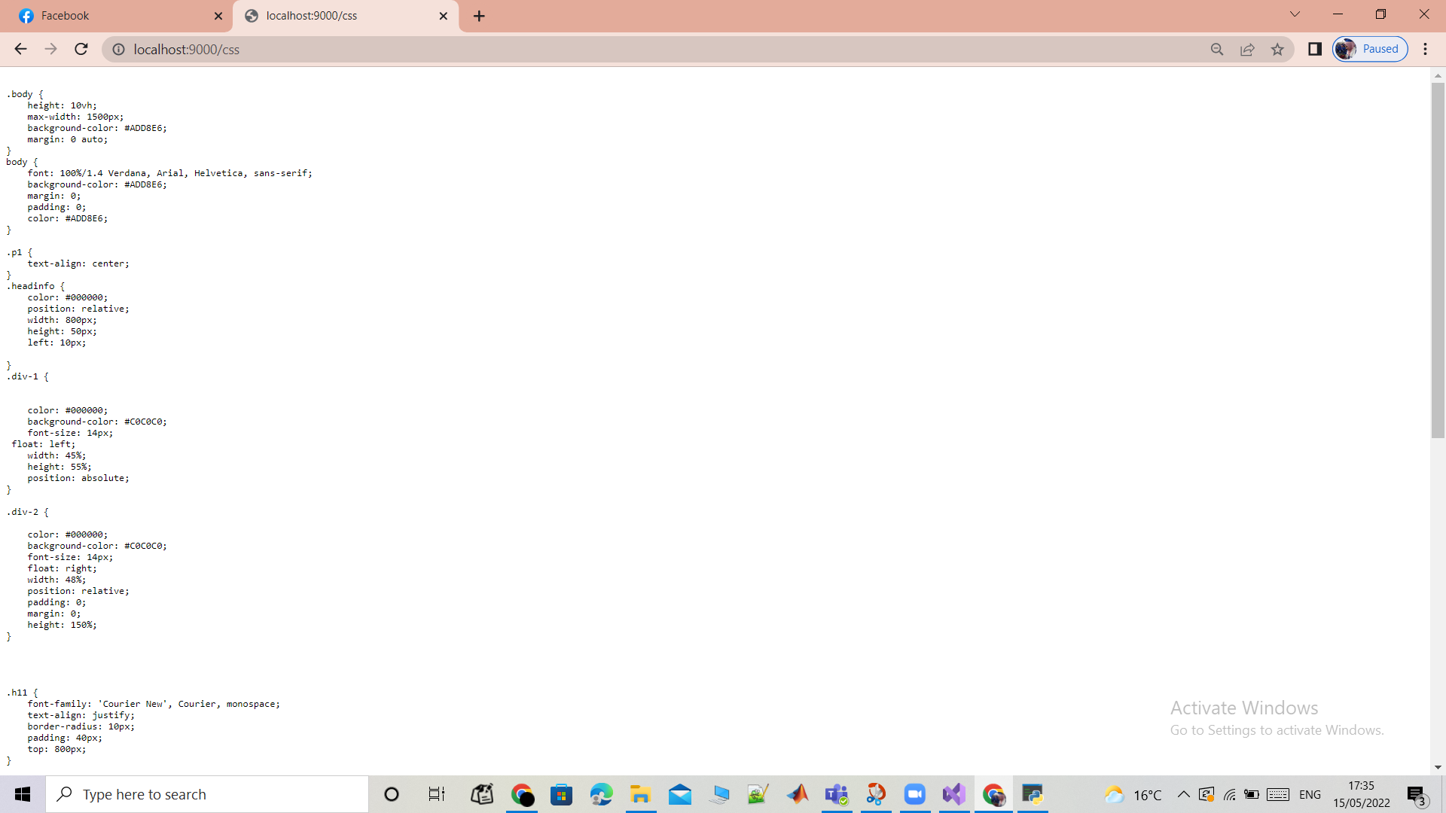

Fig3.5: .css page

If the request is a .jpg , the picture with the same name will appear as shown in figure 3.6 .

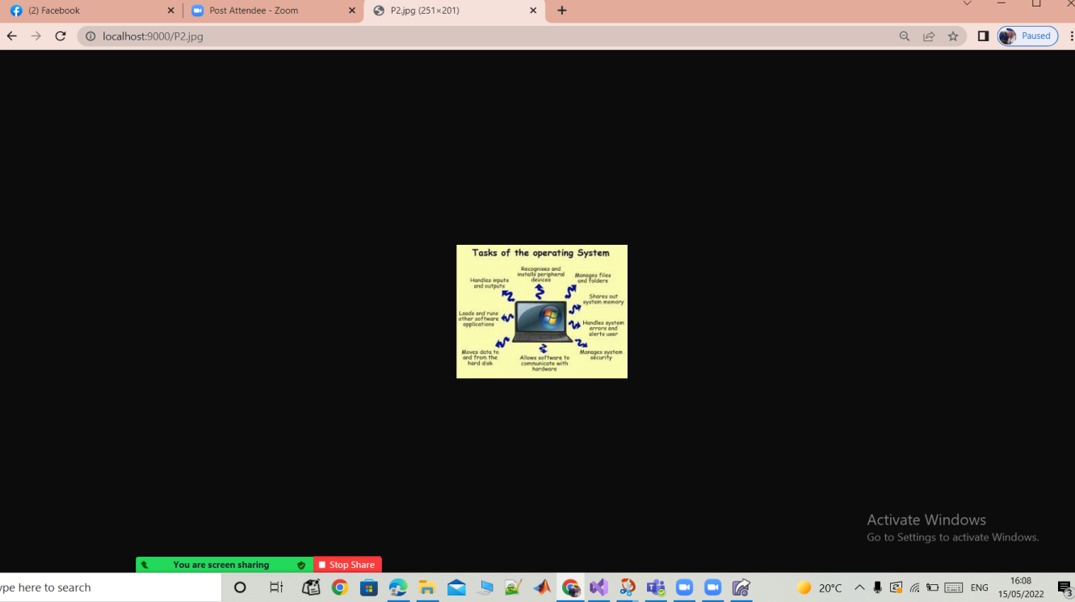

Fig3.6: .jpg page

If the request is a .png , the picture with the same name will appear as shown in figure 3.7 .

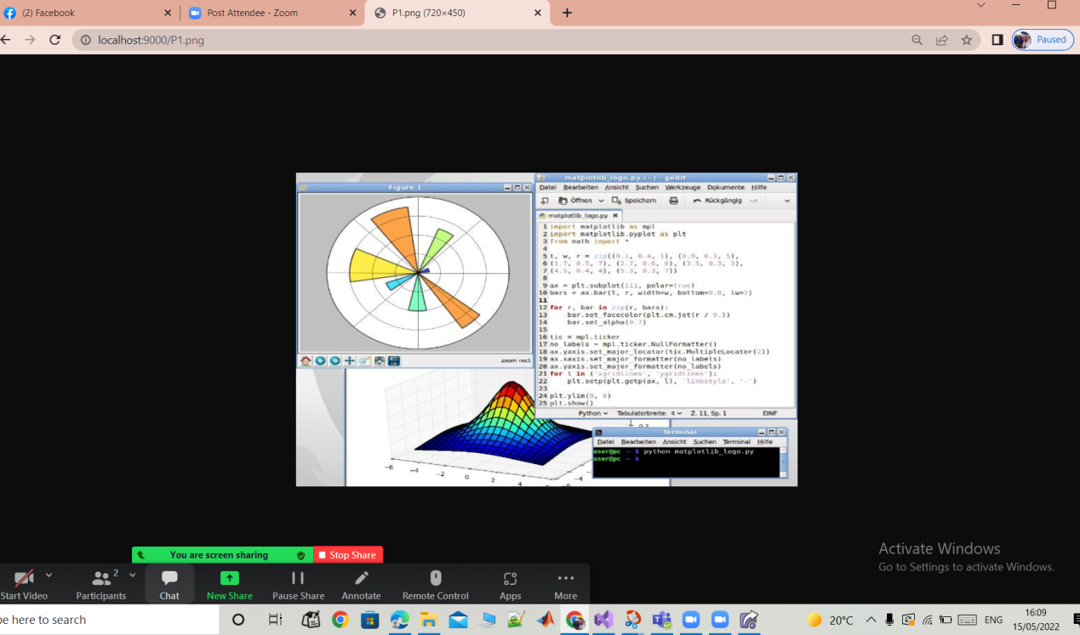

Fig3.7: .png page

If the request is /go then redirect to google website using the status code 307 Temporary Redirect . The [google.com](http://www.google.com) page will appear as shown in figure 3.8 and 3.9

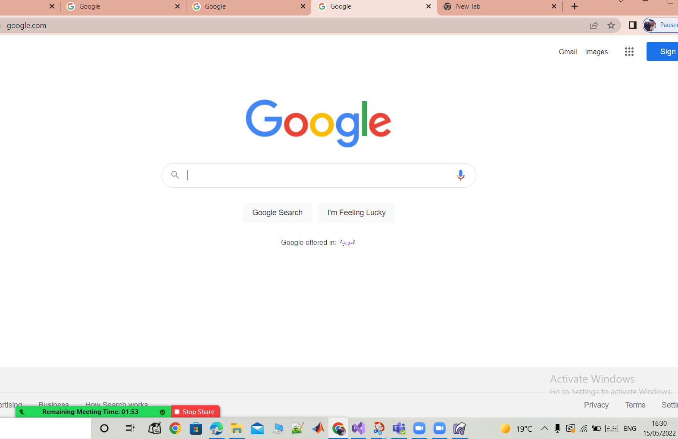

Fig3.8: google page

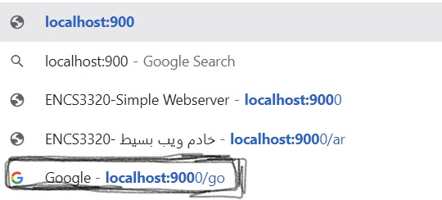

Fig3.9: google page

If the request is / cn then redirect to cnn website using the status code 307 Temporary Redirect . cnn page will appear as shown in figure 3.10 and 3.11



Fig3.10: cnn page

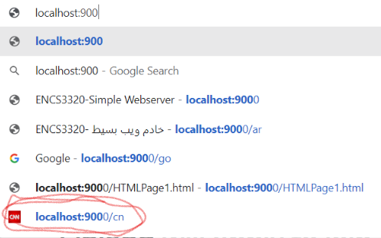

Fig3.11: cnn page

If the request is /bzu then redirect to birzeit university website using the status code 307 Temporary Redirect . bzu page will appear as shown in figure 3.12 and 3.13

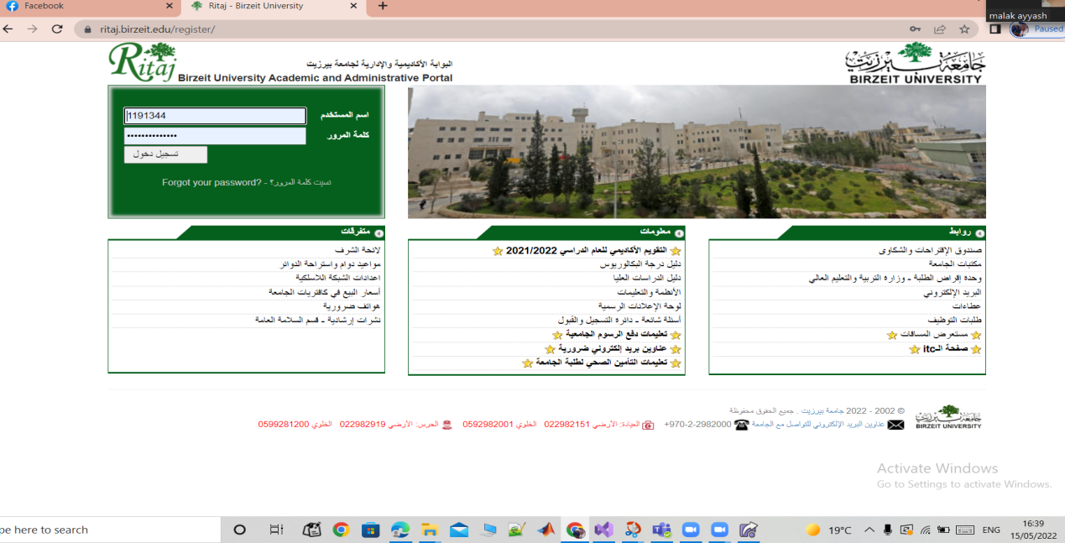

Fig3.12: birzeit university website

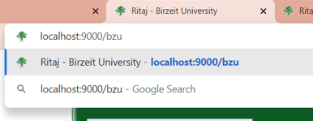

Fig3.13: birzeit university website

If the request is wrong or the file doesn’t exist the server should return a simple HTML webpage as sown in figure 3.14

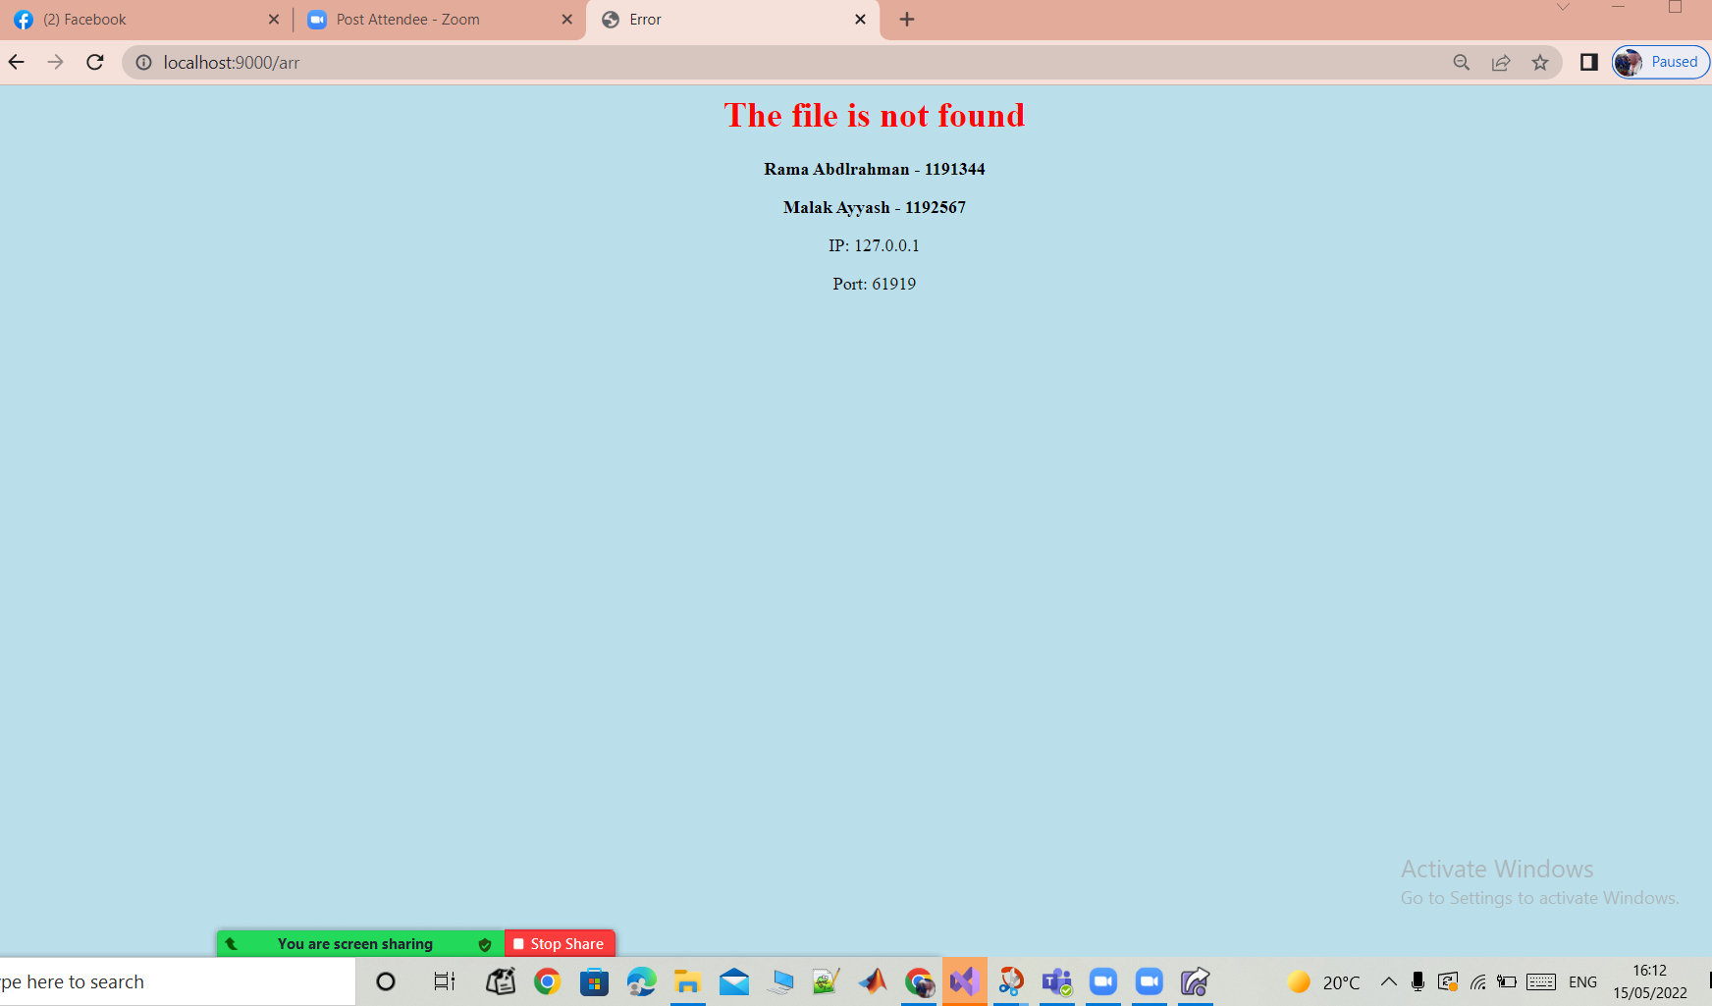

Fig3.14: error page

# Conclusion

in this project which consists of two pats, we have learned how to run some commands, we have studied and explained each of them like Ping , tracert and nslookup. Also Using socket programming, we implemented a simple but a complete web server in python that is listening on port 9000. The user types in the browser something like [http://localhost:9000/ar](http://localhost:9000/ar?fbclid=IwAR0MeNNBCmumFmE2kI_bCcQyQhi89Xp7Tp7AVkOdgIA0ZD03F4PyZ1tqGb0) or [http://localhost:9000/en](http://localhost:9000/en?fbclid=IwAR2Mnlh5hhDqChXNwGbO7Fzyh9_889SA3Ce67YguYfkKSB3TibbMz4vXc4U) . The program checked different requests and explained the response of each.

# Reference

1. [https://stackoverflow.com/questions/9233027/unicodedecodeerror-charmap-codec-cant-decode- byte-x-in-position-y-character](https://stackoverflow.com/questions/9233027/unicodedecodeerror-charmap-codec-cant-decode-%20%20%20%20%20byte-x-in-position-y-character) ," 3 May 2022 . [Online].

2. [https://www.w3schools.com/cssref/pr\_background-color.asp](https://www.w3schools.com/cssref/pr_background-color.asp?fbclid=IwAR0rkMTMCKNILp6pnhLAAymqhPMLQ4luyEv4i0mXGdt-utTWo3j9bfEY44s)," 4 May 2022 [Online].

3. [Ping Test check my ping - ping-test.net](http://ping-test.net/) ," 5 May 2022 . [Online].

6. [How to Use the Tracert Command in Windows (lifewire.com)](https://www.lifewire.com/tracert-command-2618101) ," 5 May 2022 . [Online].

7. [What Is NsLookup? Use Our Online Tool To Query DNS Records - Network Tools (network-tools.com)](https://network-tools.com/nslookup/)," 5 May 2022 . [Online].

# Appendix

1. Cmd for main en :

# C:\Users\hghg\Downloads\280632589_1324329974726735_8725818045145696999_n.png

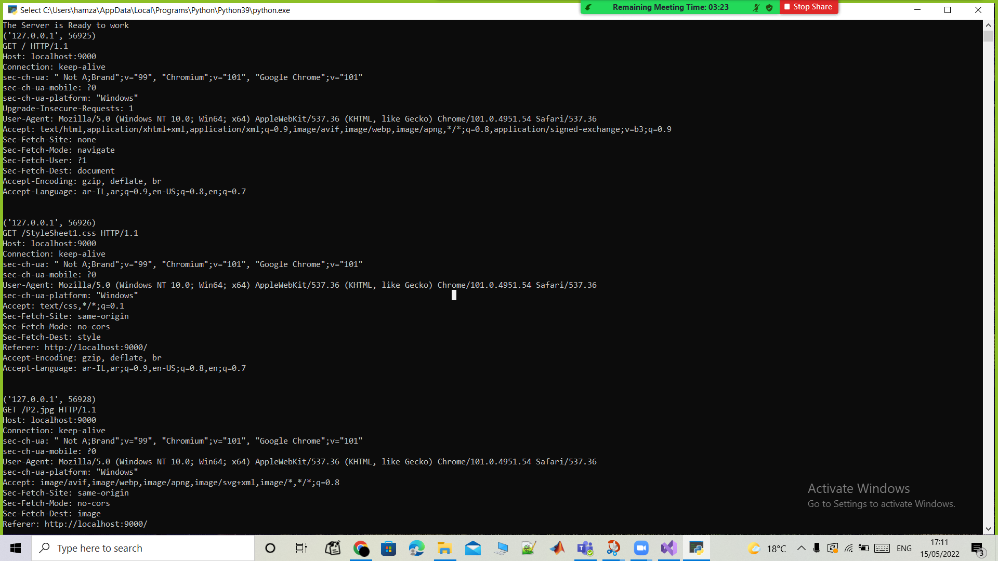

2. main ar :

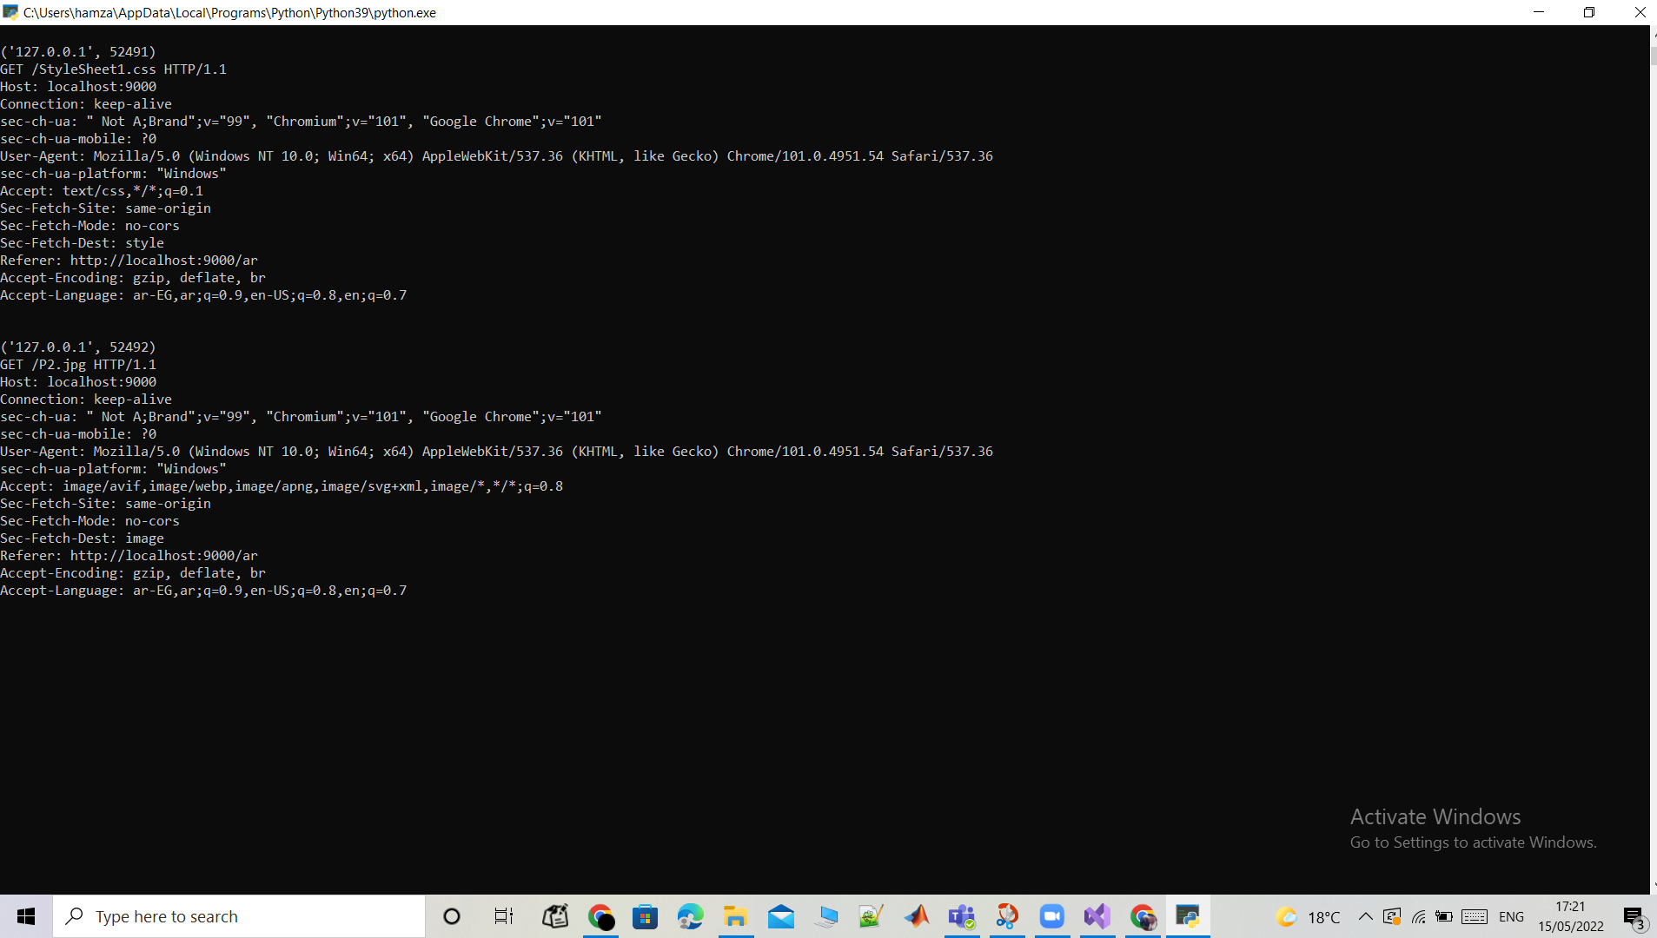

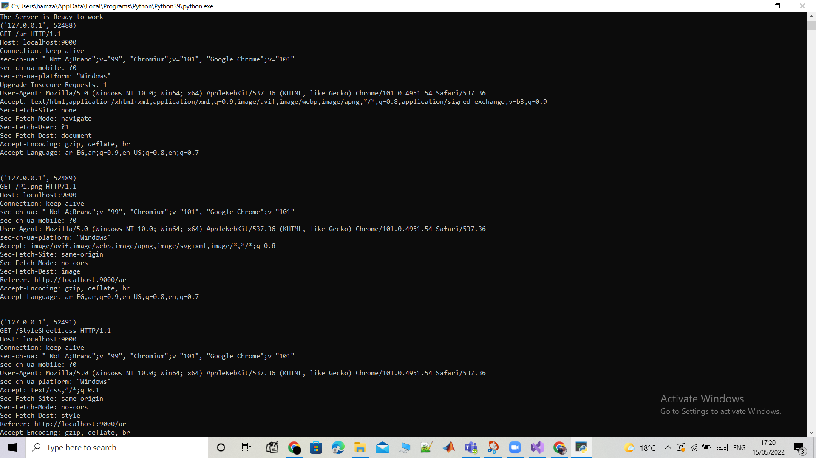

3. css

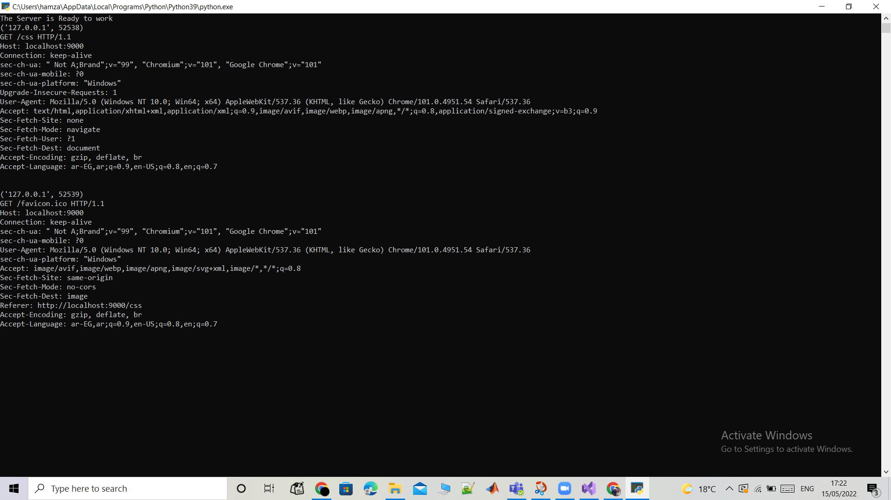

4. error

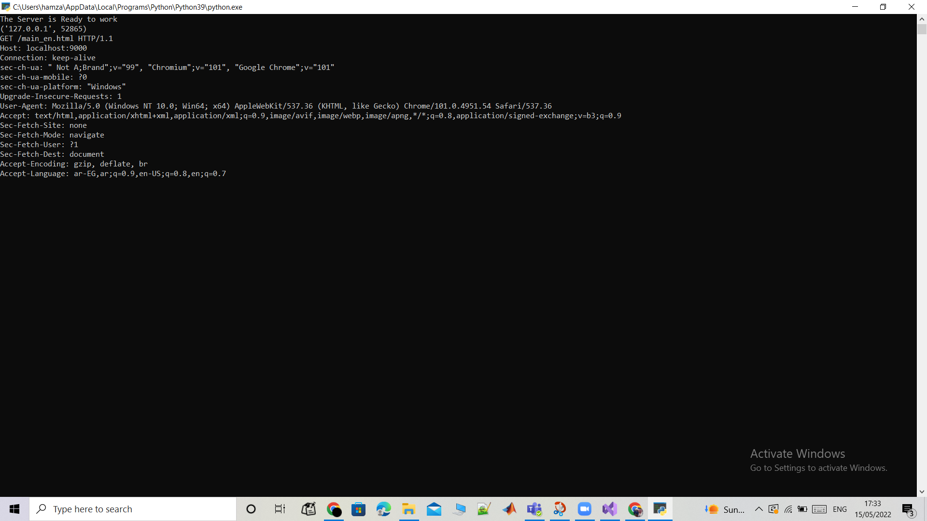

Python code:

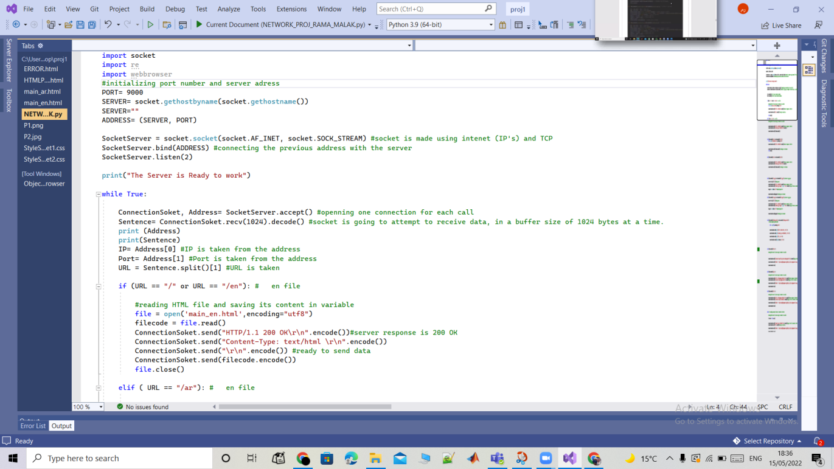

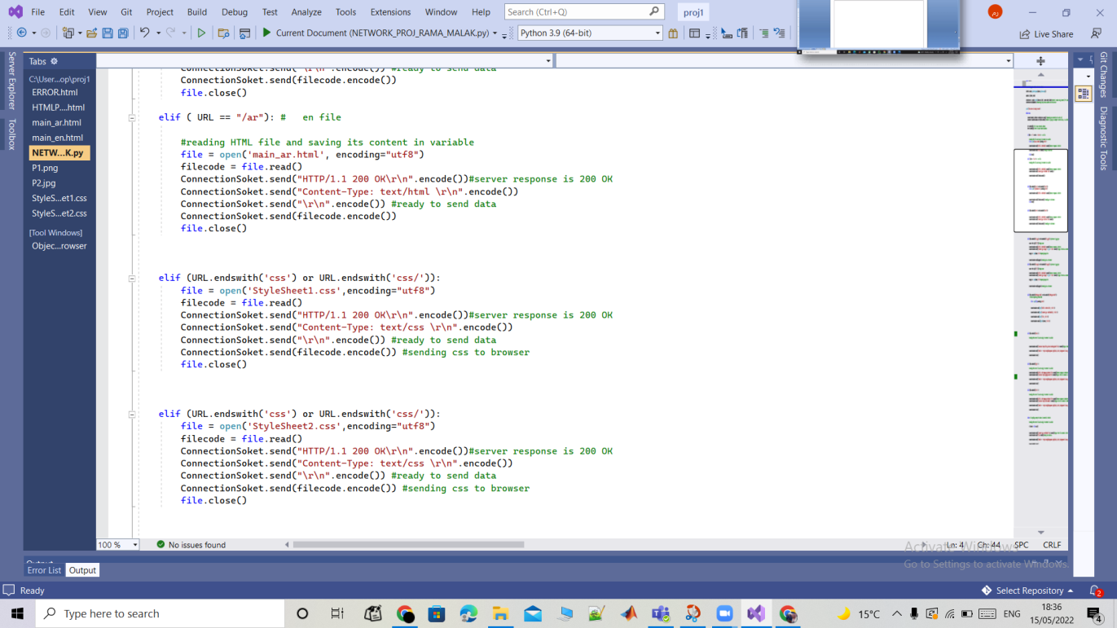

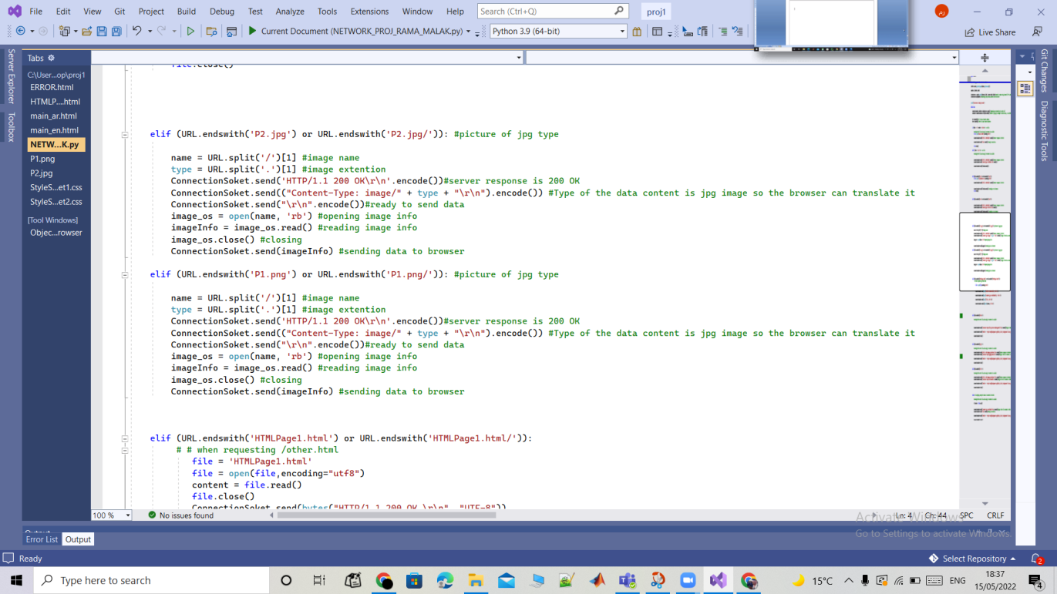

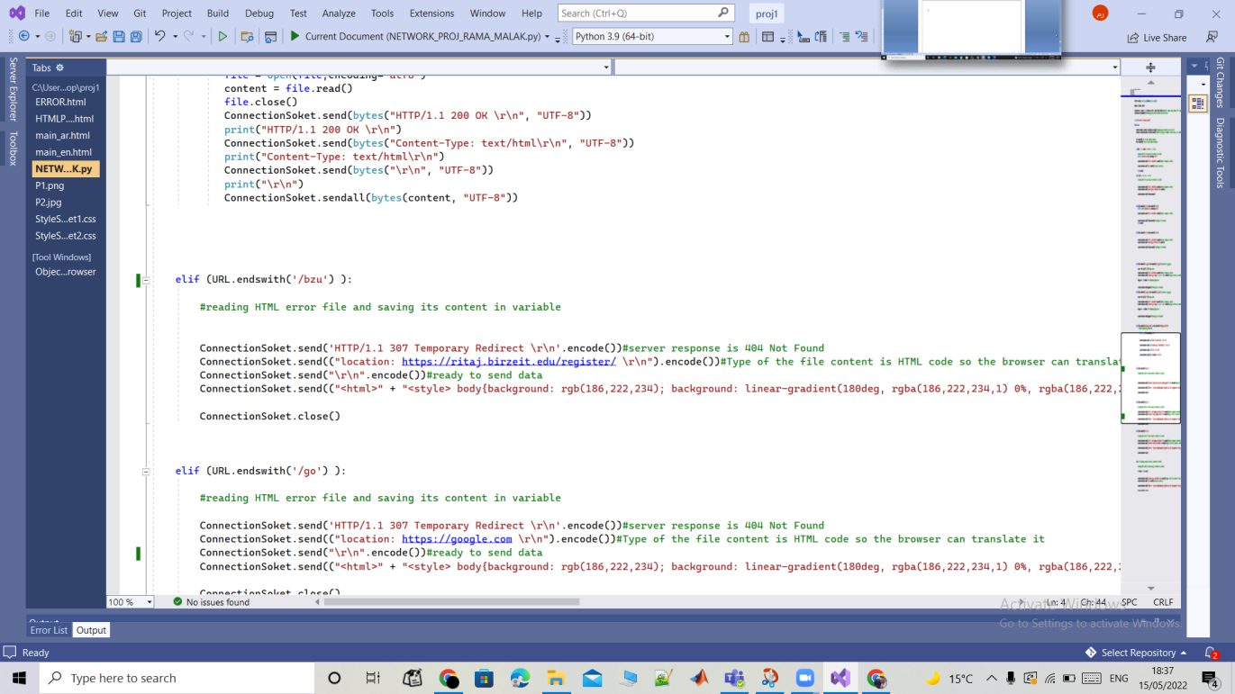

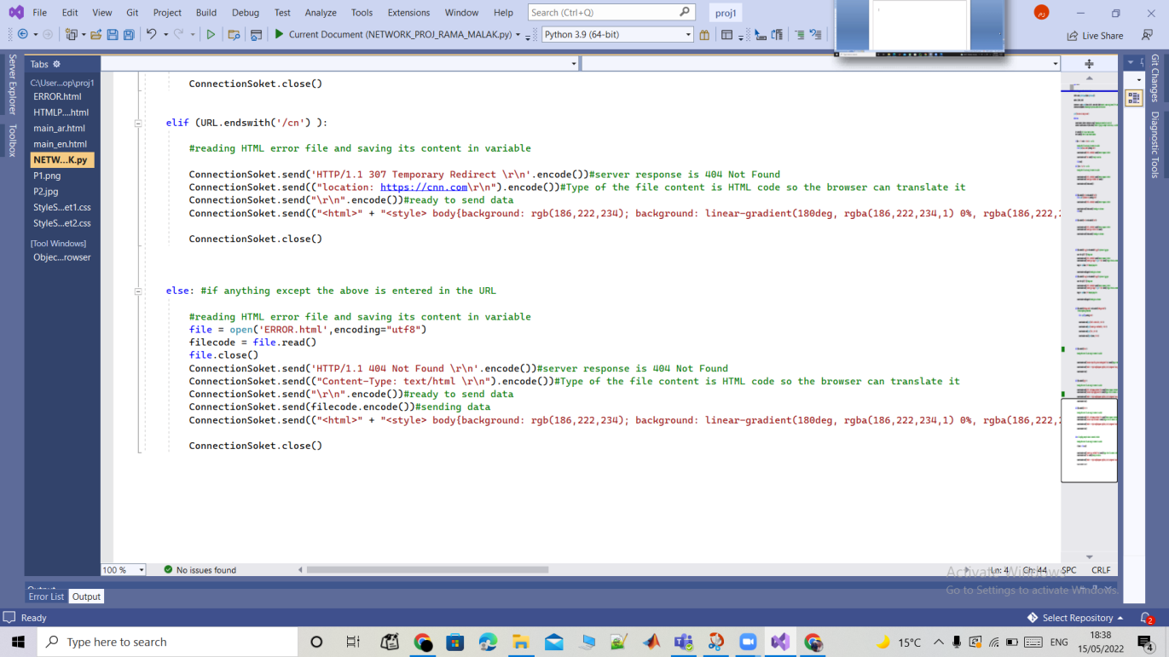

Main\_en:

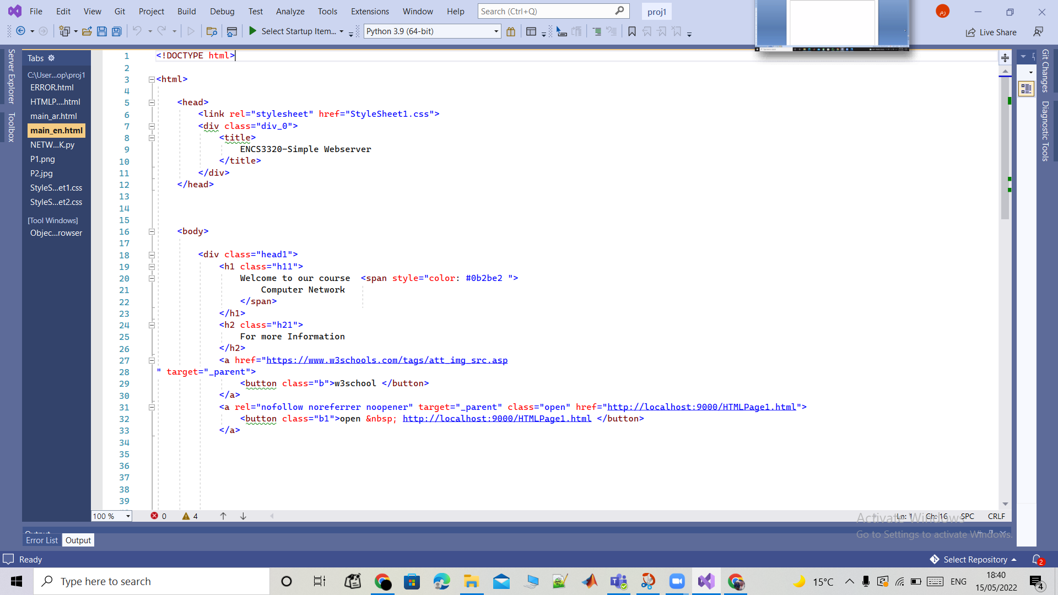

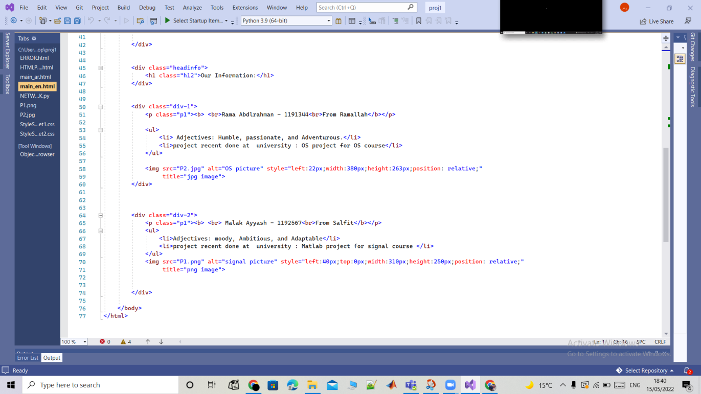

Main\_ar :

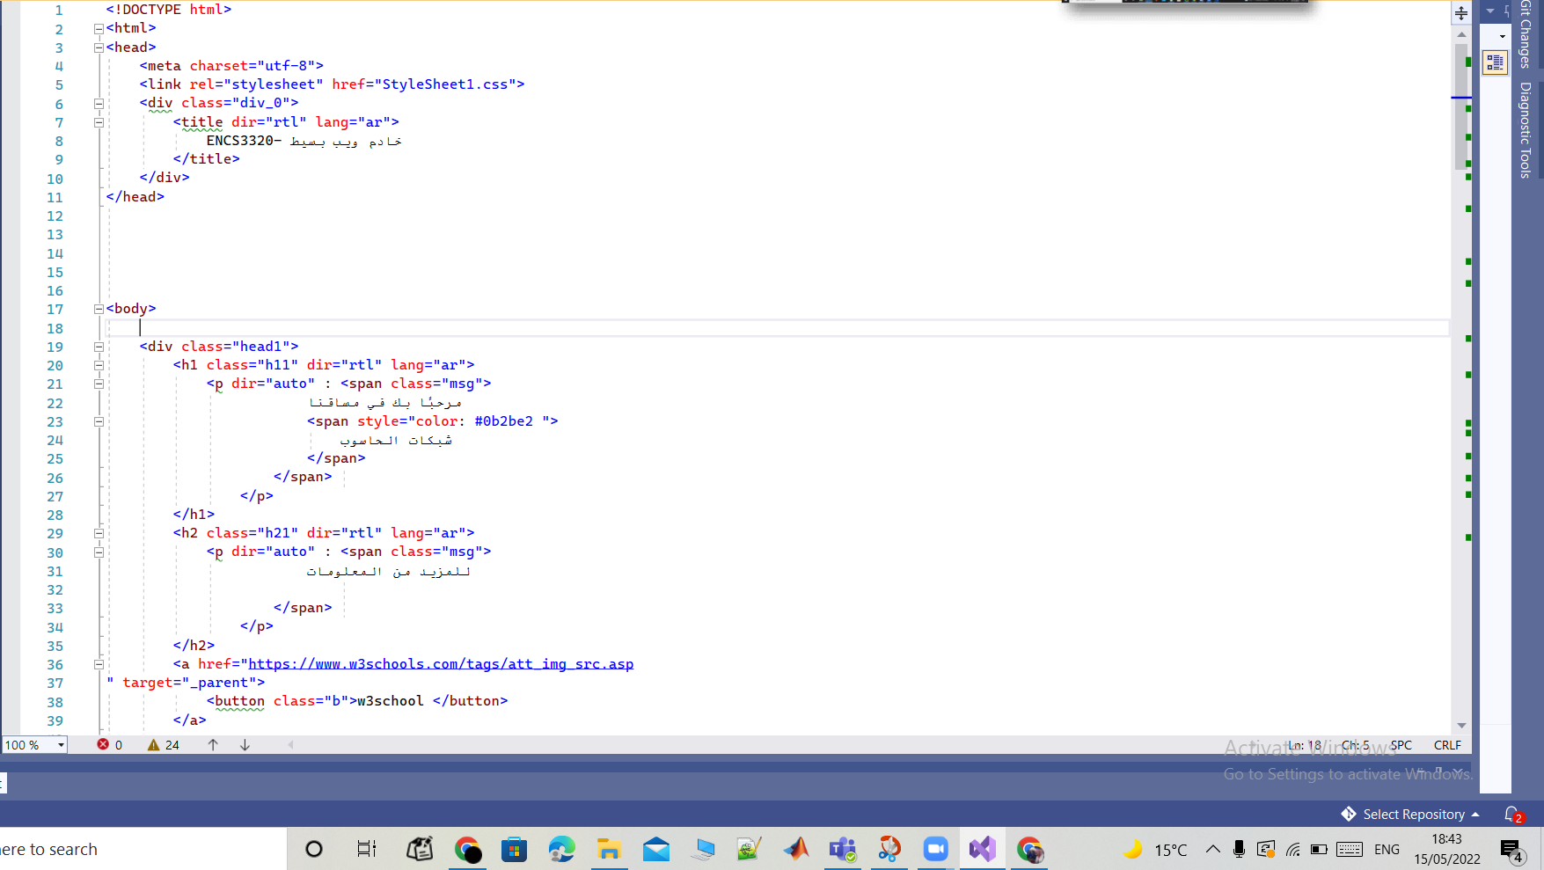

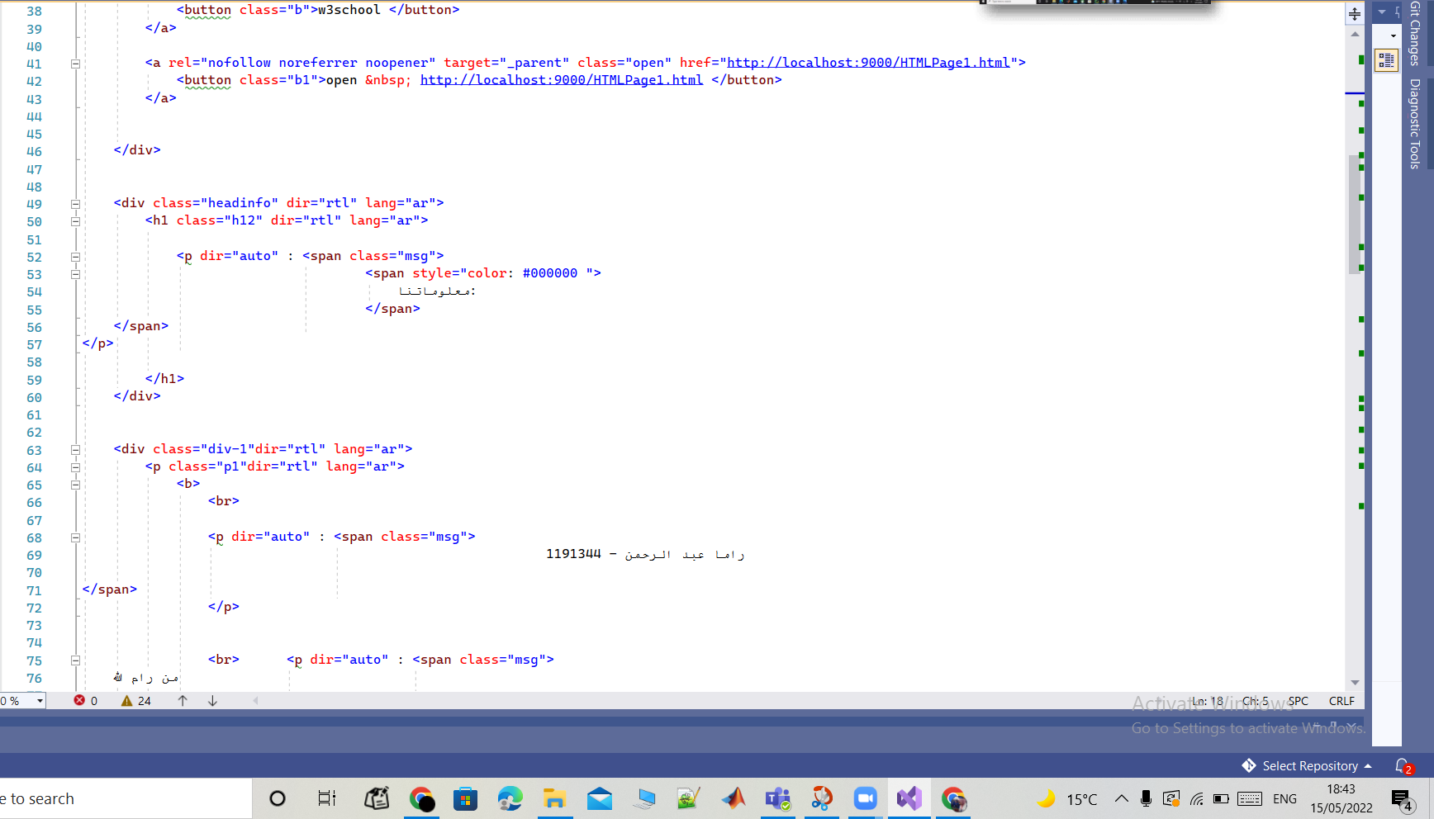

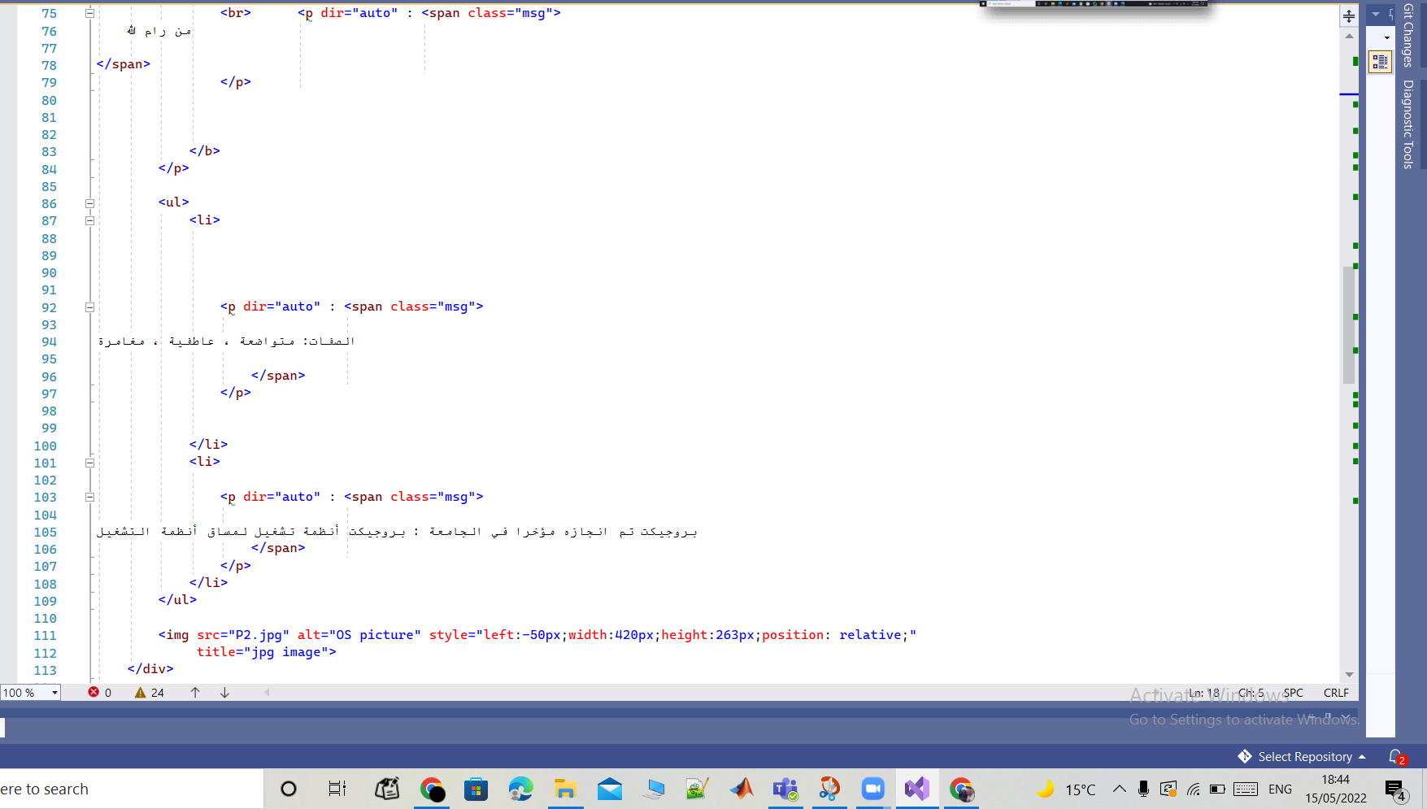

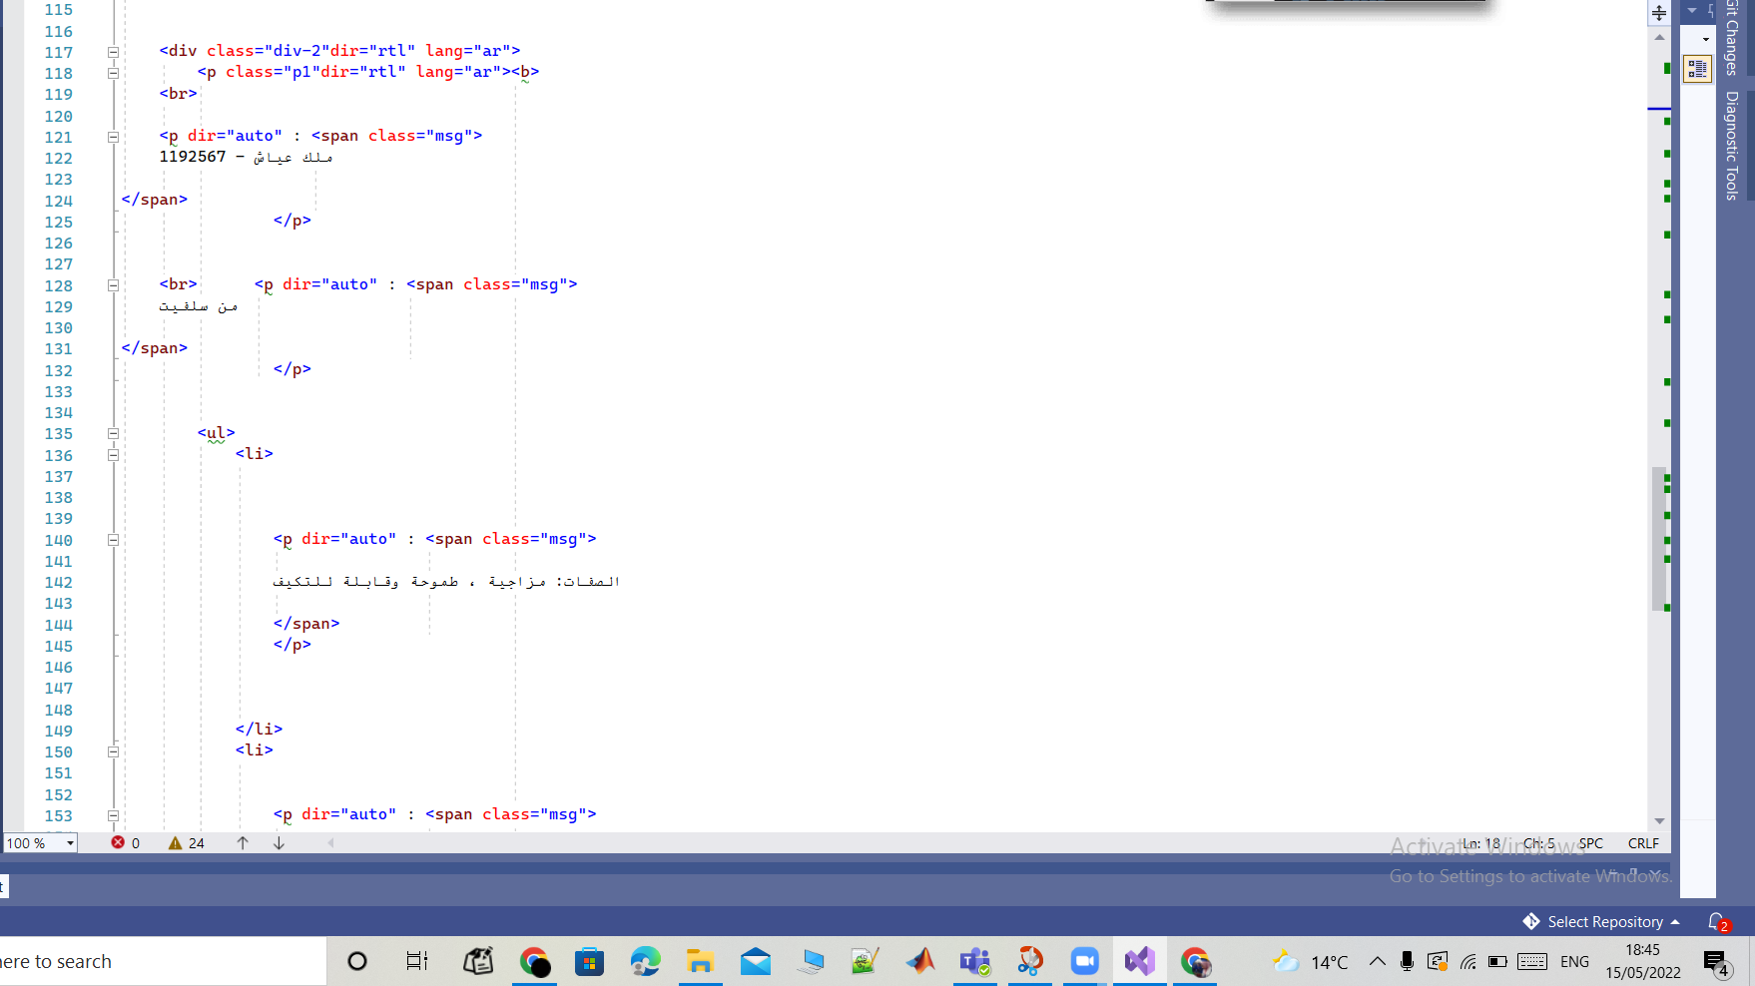

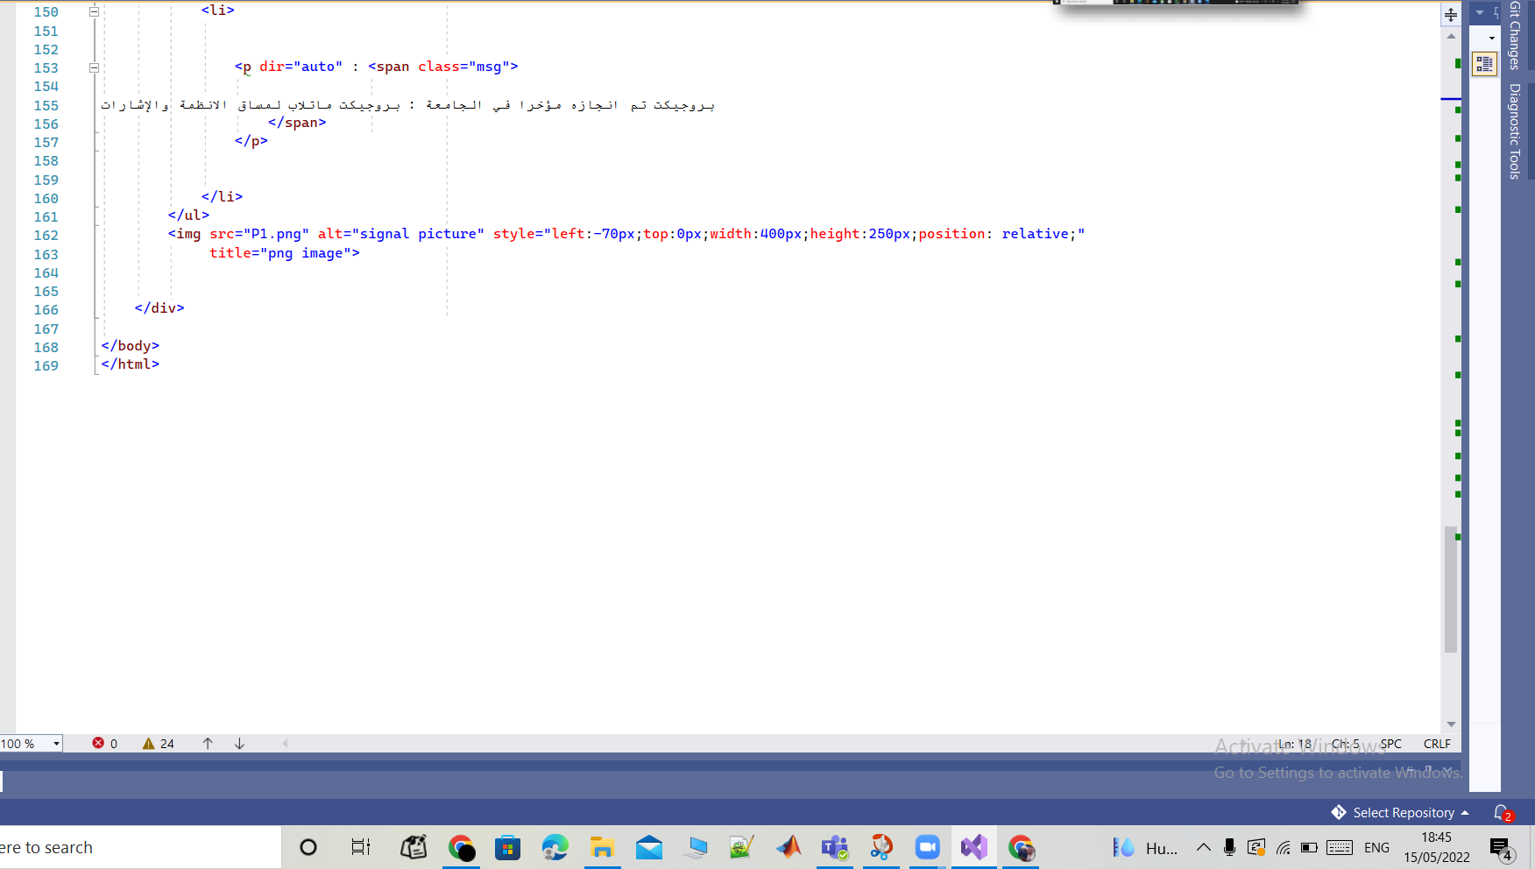

Error code :

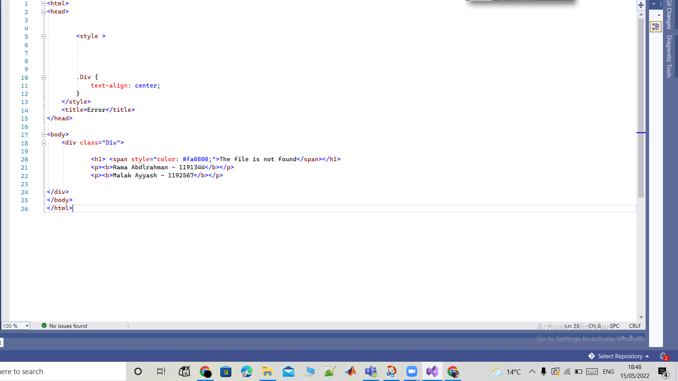

Css code :

